2200031128 CH BHAVANA
WEEK 8 TASK 4
Objectives
- Explain how to resolve the conflict during merge.
In this hands-on lab, you will learn how to:
- Implement conflict resolution when multiple users are updating the trunk (or master) in such a way that it results into a conflict with the branch’s modification.
Prerequisites
The following are the pre-requisites to complete this hands-on lab:
- Hands-on ID: “Git-T03-HOL_001”
Notes*:
Please follow the below steps for creating a free account in GitHub.
Do not use cognizant credentials to login to GitHub.
Estimated time to complete this lab: 30 minutes.
Please follow the instructions to complete the hands-on. Each instruction expect a command for the Git .
- Verify if master is in clean state.
- Create a branch “GitWork”. Add a file “hello.xml”.
- Update the content of “hello.xml” and observe the status
- Commit the changes to reflect in the branch
- Switch to master.
- Add a file “hello.xml” to the master and add some different content than previous.
- Commit the changes to the master
- Observe the log by executing “git log –oneline –graph –decorate –all”
- Check the differences with Git diff tool
- For better visualization, use P4Merge tool to list out all the differences between master and branch
- Merge the bran to the master
- Observe the git mark up.
- Use 3-way merge tool to resolve the conflict
- Commit the changes to the master, once done with conflict
- Observe the git status and add backup file to the .gitignore file.
- Commit the changes to the .gitignore
- List out all the available branches
- Delete the branch, which merge to master.
- Observe the log by executing “git log –oneline –graph –decorate
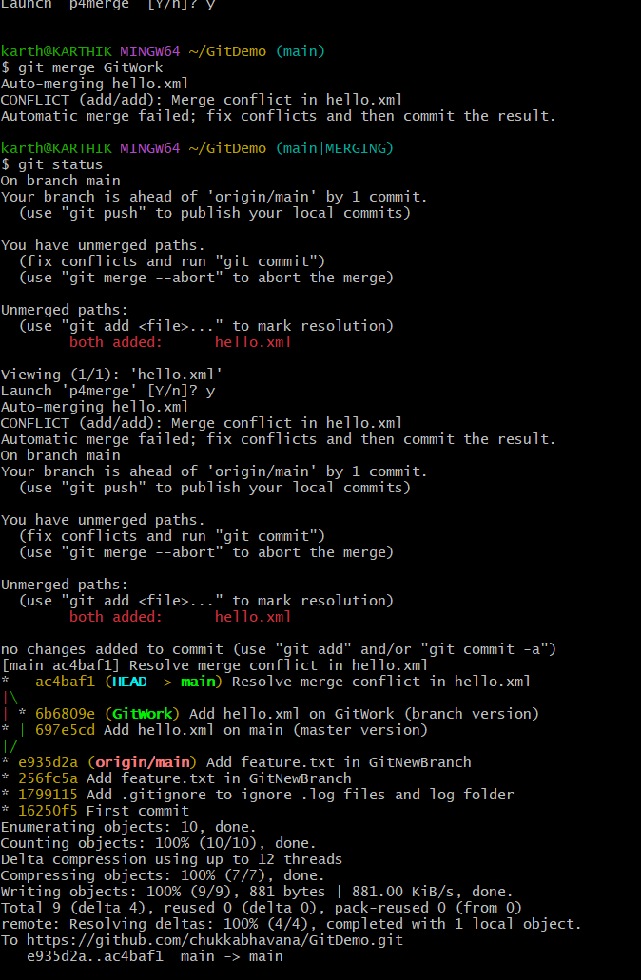
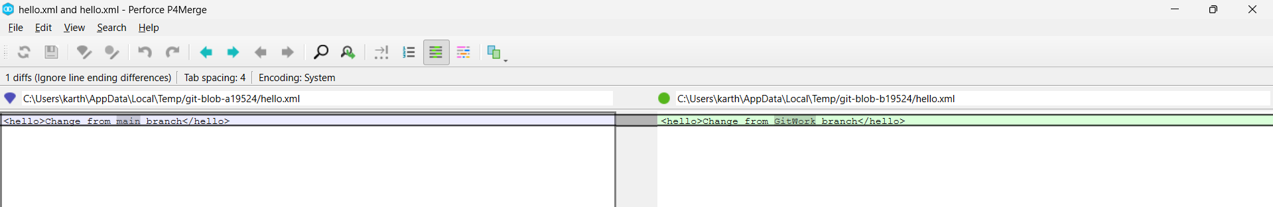
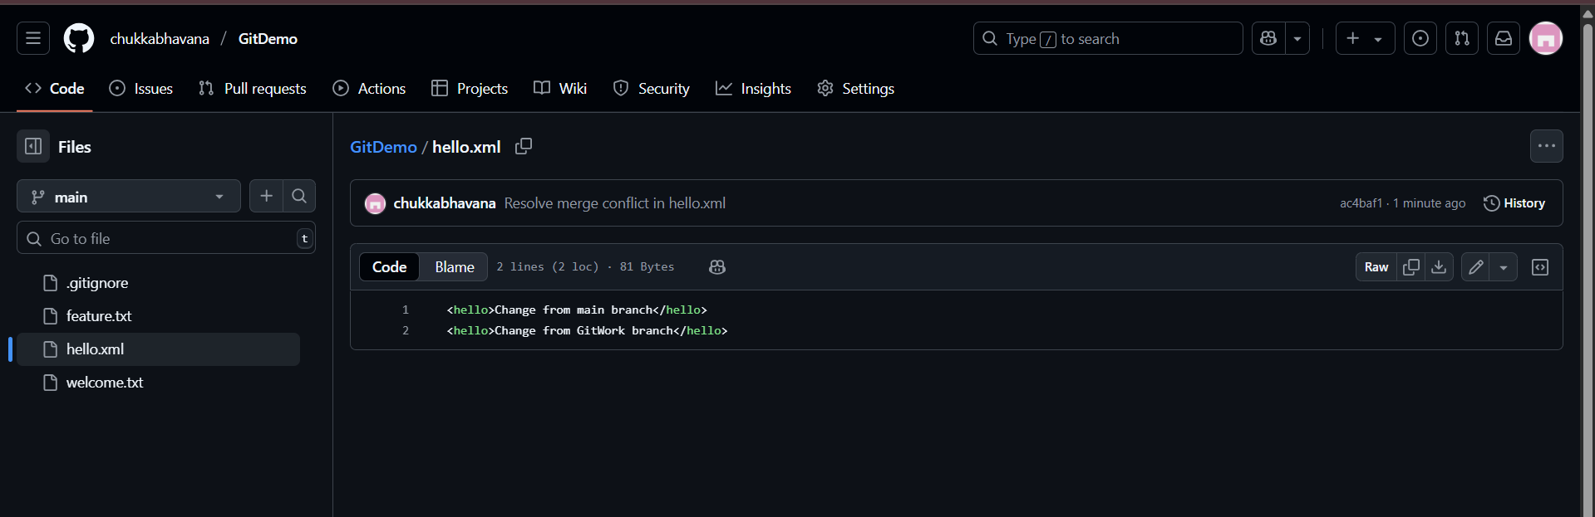
Merge Conflicts in Git
1. How merge conflicts happen
- Git tries to automatically combine changes from two branches.
- A merge conflict occurs when:
  - The same file has changes in the same lines in both branches, and
  - Git can’t decide which change to keep.
- Example: both main and GitWork ed the same <hello> line in hello.xml.
2. Conflict markers in the file
When a conflict happens, Git stops the merge and marks the file with:
pgsql

<<<<<<< HEAD
(change from your current branch, e.g., main)
=======
(change from the branch you’re merging in)
>>>>>>> branch-name
- HEAD → your current branch version
- After ======= → the incoming branch’s version
- >>>>>>> → name of the other branch

3. Resolving the conflict
You, as the developer, must:
- Open the file in an or or merge tool (e.g., Notepad, P4Merge).
- Decide on the final content (choose one side, combine both, or rewrite).
- Remove the conflict markers (<<<<<<<, =======, >>>>>>>).
- Ensure the file’s syntax is correct after ing.
4. Marking the conflict as resolved
- Once fixed, you tell Git the conflict is resolved: git add <file>
- Then finish the merge with: git commit
- The commit will be a merge commit (unless it was fast-forwarded earlier).
5. Handling merge tool backups
- Some merge tools create backup files (e.g., *.orig, *~).
- You should ignore these in .gitignore so they don’t get committed:
markdown
*.orig
*~
6. Cleaning up
- After merging, you can safely delete the temporary branch:cgit branch -d <branch>
- This removes the branch pointer but not the commits (history remains).
7. Push the result
- To share the merge result with others:cgit push
8. Summary
- Merge conflicts are normal in collaborative work.
- They require human judgment to resolve.
- Git provides both command-line and GUI tools to help.
- Once resolved, the branches’ histories are combined in the target branch.

